# CS 255 System Design Document Template

This template lays out all the different sections that you need to complete for Project Two. Each section has guidance to prompt your thinking. You will need to continually reference the interview transcript as you work to make sure that you are addressing your client’s needs. There is no required length for the final document. Instead the goal is to complete each section based on what your client’s needs are. Remove this note when you are finished, and replace all bracketed text with the relevant information.

## UML Diagrams

### UML Use Case Diagram

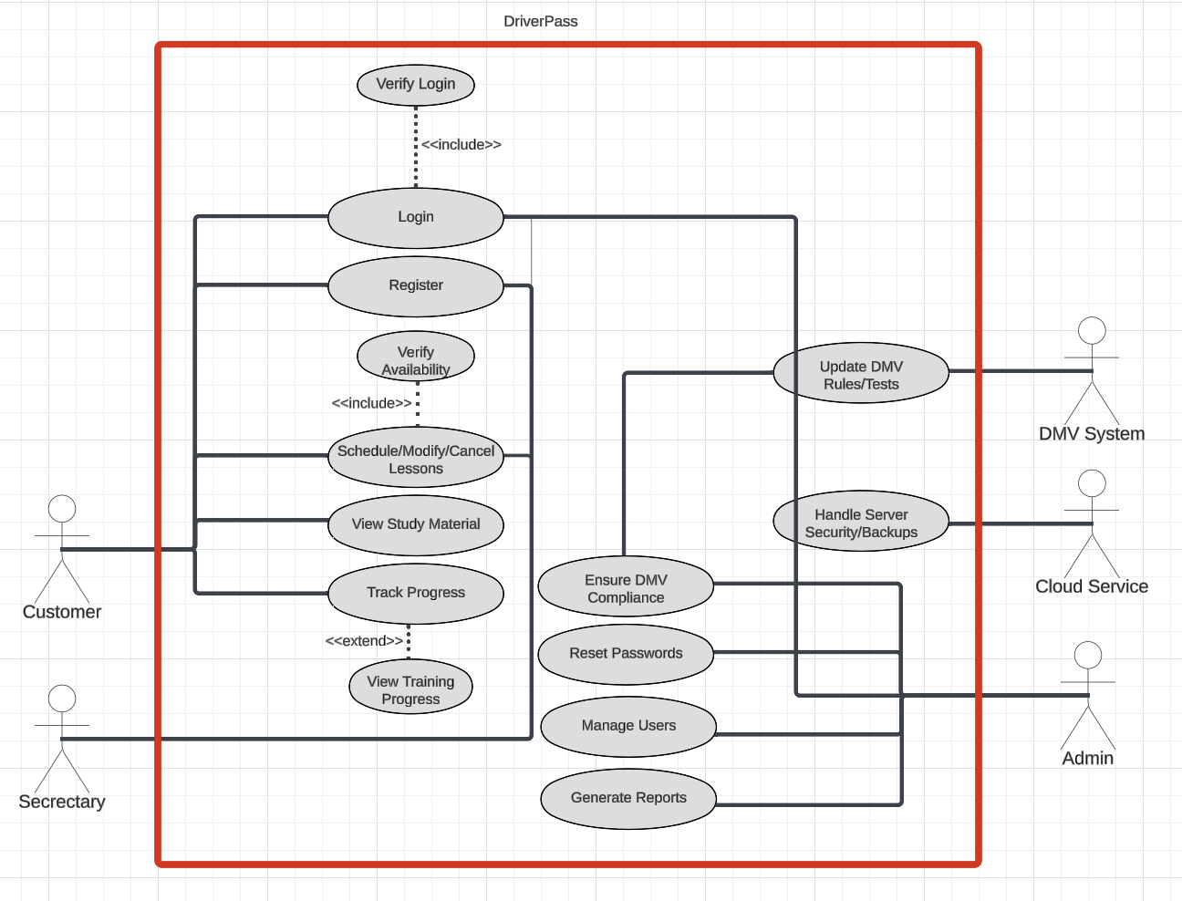

### UML Activity Diagrams

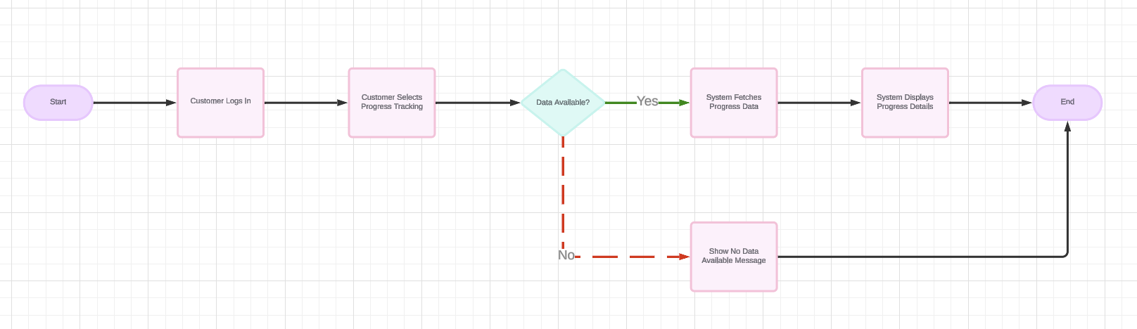

*

### UML Sequence Diagram

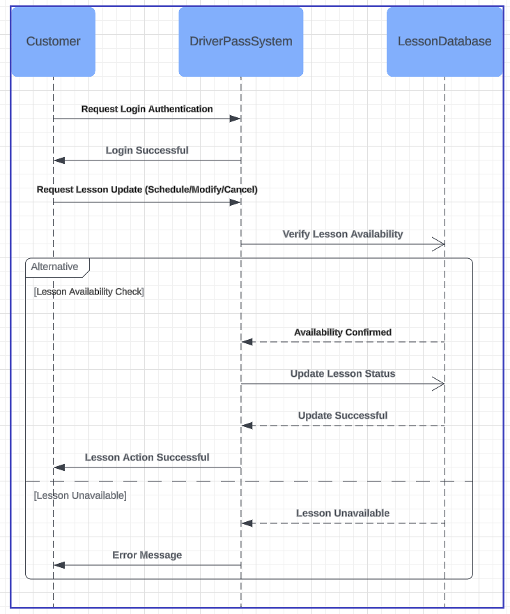

### UML Class Diagram

## Technical Requirements

**Hardware Requirements**

* **Servers**: Reliable servers capable of hosting DriverPass and storing its data. They should include sufficient storage and processing power for simultaneous user access without performance drops.
* **Client Devices**: Users should have a modern browser (such as Chrome or Firefox) and a computer with at least 4GB of RAM and a dual-core processor to ensure smooth operation.

**Software Requirements**

* **Operating System**: A stable Linux distribution (e.g., Ubuntu) on the servers ensures reliability and support.
* **Database**: MySQL or PostgreSQL is recommended for managing user data, lesson schedules, and payments.
* **Programming Tools**:
  + **Backend**: Java or Python for server-side business logic.
  + **Frontend**: HTML, CSS, and JavaScript for user interaction.
* **Web Server**: Apache or NGINX for handling incoming requests and delivering responses.

**Network Requirements**

* **Bandwidth**: A reliable, high-speed internet connection to prevent delays or downtime.
* **Security**: HTTPS for secure data transmission, supplemented by firewalls and timely software updates to prevent breaches.

**Functional Requirements**

* **User Management**:
  + Login functionality with account lockout after too many failed attempts.
  + Progress tracking and lesson scheduling for users.
* **Lesson Management**:
  + Real-time capabilities for scheduling, modifying, or canceling lessons.
* **Payment System**:
  + Secure credit card validation for purchasing lesson packages.
* **Admin Features**:
  + Reporting capabilities and tools to manage user accounts.

**Nonfunctional Requirements**

* **Performance**:
  + Response times under two seconds for most actions.
* **Availability**:
  + System uptime of at least 99%.
* **Scalability**:
  + Ability to support thousands of concurrent users during peak periods.